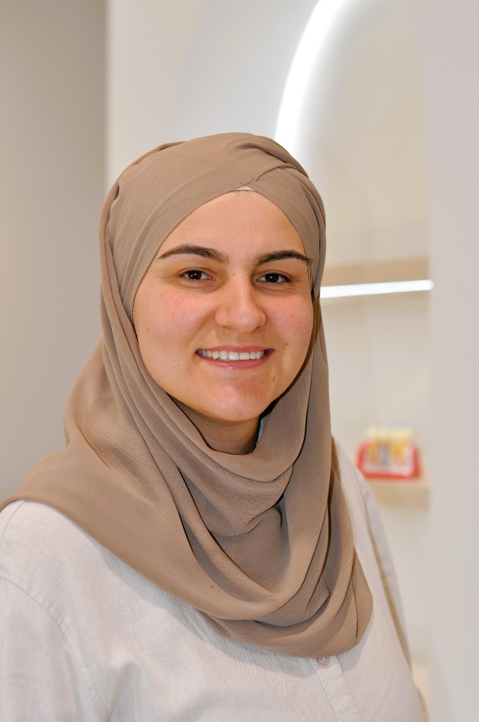
Dr Fatima Kurnaz
Principal Dentist | Founder, Y3 Smiles Dental
Dr Fatima Kurnaz is passionate about creating positive dental experiences and building long-term relationships with her patients.
After completing her dental training, she gained valuable experience working in both regional and metropolitan clinics, where she developed a deep appreciation for personalised, high-quality care. Those early years shaped her philosophy — that dentistry should be as much about compassion and understanding as it is about clinical excellence.
Now, as the Principal Dentist and Founder of Y3 Smiles Dental, Dr Fatima is proud to care for families in her own community of Hume — the place she grew up and still calls home. She believes in providing modern, gentle, and ethical dentistry where every patient feels heard, respected, and supported.
Her calm, friendly approach helps even the most anxious patients feel at ease. Whether it’s a routine check-up, restorative care, or aesthetic treatment, Dr Fatima takes the time to explain each step and tailor care to every individual’s needs.
Outside the clinic, Dr Fatima loves to bake, spend quality time with her family, and explore the outdoors — a balance that reflects her warm and caring nature both inside and outside the dental chair.

